**Market Cap (Weighted) Hated Indexes**

**Published by** [**TheItalianLeatherSofa**](https://theitalianleathersofa.com/author/protasoni2/) **on August 9, 2023**

<https://theitalianleathersofa.com/market-cap-weighted-hated-indexes/>



Index: a sign or measure of something

I have been reading complaints about market capitalisation-weighted indexes for a while. The latest reason is the over-exposure of the World Index to the US stocks…according to European investors; because if you ask Americans, there is never enough US stuff you can put in your portfolio (excluding Meb Faber).

Here I try to collect my thoughts on this matter.

**Historical Reasons**

When I was working in London, one day a colleague during a random office chit-chat told me “I lost two stones”. I replied, “Why were you going around with two stones?”. Honestly, it reminded me of when my two-year-old daughter was bringing back random sticks and pebbles after a trip to the park…but this guy was a grown-up lad. To the non-Game of Thrones audience, he meant he lost weight.

The more curious aspect is that at school they learn about kilos, centimetres and so on (not sure about litres though). English people know there is a more efficient way to measure the world out there, but some of them simply do not bother. Maybe that’s the way they do in their household, maybe it’s an anchor to the glorious past Emipire days, for whatever reason they are stuck in a world where humans did not have huge abstraction capabilities. OK Lannister.

Just to say that you should not be shocked if weird ways to measure stuff persist.

The best equivalent in the financial world is the Dow Jones Industrial Average Index. The DJIA includes only 30 stocks and it is price-weighted, meaning the value of the index is calculated as the sum of the stock prices of the companies included in the index, divided by a factor. Pretty “clever” uh? Despite this, you find references to it almost everywhere and, curiously, it tracked pretty well the S&P500:

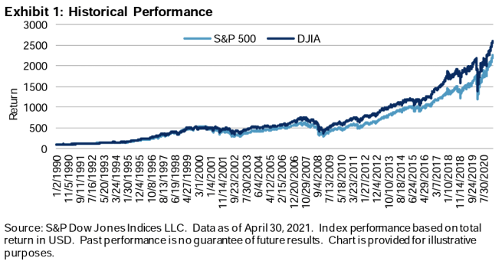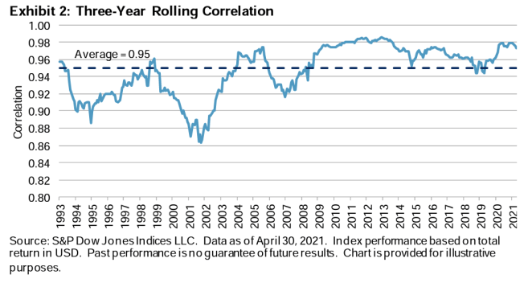

**Representativeness**

When creating an index, the complexity of collecting information and the representativeness in respect of the reality it tracks goes hand-in-hand. Usually, completeness is sacrificed to the altar of practicality, speed, or both. Think about another personal finance fan-favourite index: the CPI. Imagine how long it would take to gather a very broad set of prices: it is better to have something decent with less than a two-week delay or something more precise with a bigger lag? Will we ever even agree, as a society, what *decent* means? If I consider all the debates I read around, from the owners’ equivalent rent concept to the various conspiracy theories, I am not that positive.

*Standard & Poor’s current market capitalization-weighted tracking of 500 stocks took form in 1957. The provider was seeking a way to track the market in aggregate to generate a view of the investment experience of investors as a collective, and the index it invented was, rightly, capitalization weighted. That means the objective was not to find investment optimization based on a reading of the academic literature, but more likely the need at S&P’s headquarters to come up with an index that would approximate the public’s total returns.*

The S&P500 was the first index to use the market cap-weighted methodology. The logic is simple: the higher a stock market capitalisation, the higher the probability that stock would be in someone’s portfolio. If your index goal is to represent the average investor performance, this would do. Even with the 50’s tech, pen and paper, the index was relatively easy to compute: S&P could publish it on a timely manner. Later, the index became also float-adjusted, meaning the share counts used in calculating the index only reflect those shares available to investors rather than a company’s total outstanding shares. Again, representativeness.

To me, the market-cap-weighted methodology seems to do pretty well what it was designed to do.

Issues start to arise when we take a tool that was conceived to achieve A and use it to do B. I do not blame you if you desire B, just make sure you adopt the proper tool.

We live in a complex world. Zurich is regularly in the Top 10 ranking of the most liveable cities in the World; if my wife wouldn’t know better, she would have been (even more) disappointed to move here by choosing according to those rankings alone. The ranking is based on average preferences, while my wife has her own, and her own circumstances as well. You cannot blame the ranking if it does not fit your criteria…especially if you did not check them first.

The FTSE 100 tracks the 100 biggest stocks listed on the London Stock Exchange. For a long time, investors could easily access only stocks listed on their country’s stock exchange(s); for this reason, the FTSE 100 represented well the average return for an English investor. If you are interested in getting exposure to the United Kingdom risk (however you define it, since the correlation between GDP growth and stock market returns is not that stable and high-growth countries do not necessarily make for good investments), the FTSE 100 might be a rather fine to a terrible proxy for it. Why? Simply because it was not designed to track that. UK-based companies might decide to list their stocks somewhere else (see ARM) and foreign companies might decide to list in the UK (see Glencore); most likely, at the top of the list you would find companies that generate most of their revenues and profits outside the UK. For sure, the FTSE 100 is a terrible proxy if you want to get exposure to GBP; look what happened in the aftermath of the Brexit referendum:

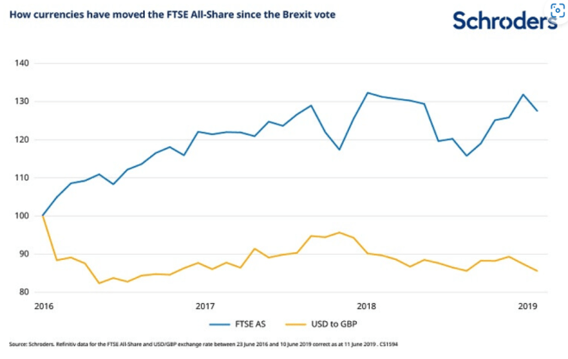

The FTSE went up while GBP went down. This, again, is a matter of where revenues and profits come from but also how companies decide to hedge their FX risk. The composition of the index, for example the weight of domestic earners vs overseas, determines how the index performs under different economic scenarios:

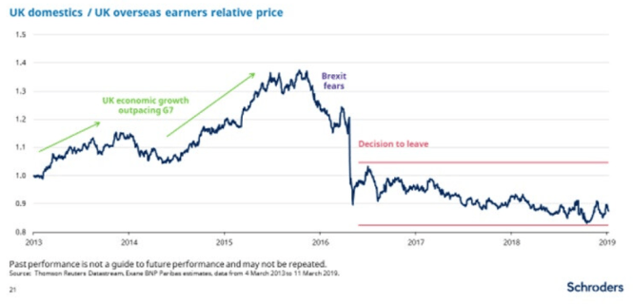

The index composition, the relative weights and the strategy of the companies it tracks change frequently enough to make any relationship with economic forecasts (and good luck nailing them) hard to follow, especially for non-professional investors.

This is why I get crazy when I read “The MSCI World Index has too much US”. What does it mean? As things stand today, there is no idiosyncratic risk in the US that would not massively affect the rest of the world. The market and index providers take into consideration the strength of the rule of law: the US has and can reach such a weight because the risk of a crazy policy change (expropriation, capital controls, you name it) is way lower than in China, for example. And as I explained above, what is labelled as “US” from a country point of view is not necessarily “US” from a financial risk point of view. There were two “Russian” companies in the FTSE 100 before the Ukraine war and they got obliterated like the Russian ETF Index.

Do we agree that Apple should have a greater weight than an Italian small cap in an index that wants to represent the average return for a global investor? If we do, then your issue with the “concentration risk” is not with that risk itself, because you accept a deviation from the equal weight ideology. Your issue is with what the market accepts as maximum concentration vs your personal appetite. Which leads us to the infamous “Are you sure you can do better than the market?”.

I bet index providers would love to have a more meaningful way to display their index country exposures, be it in terms of revenues or profits or…risk of delisting due to a belligerent tyrant? Maybe one day they will manage. I am still not sure how *you* would generate a profit out of that information though. The difference in market cap of Generali, AXA and Allianz, three European insurers based in three different countries, already reflect Mr Market’s opinion on any idiosyncratic risk they have. They are priced based on where they are based but also relative to each other. By playing with the weights in the MSCI World Index, adding regional indexes and therefore reducing the weight to World, you are re-stating those relative valuations.

During the European Debt Crisis of 2012, Coca-Cola Hellenic Bottling Company arrived to represent 90% of the Athens Stock Exchange. The company was indeed founded in Greece in the ’60s but in those days was operating in 28 countries across 3 continents. Despite the fact that was “relatively” spared the Greece catastrophe, therefore the huge weight in the index, it risked going under just because it was in the wrong place at the wrong time: its debt was cut close to junk and lost access to financing. Soon enough, the HQ of the company was moved to Switzerland and the shares were listed on the London Stock Exchange. Imagine a company part of the FTSE 100 that has literally zero revenues in GBP and therefore provides zero exposure to GBP to its investors. Even if its shares are quoted in GBP.

This phenomenon, a company HQed in country A with revenues in country B deciding to list its stocks in country C, is only going to increase. Main hubs like the US and…the US, considering that London got killed by Brexiters and Hong Kong by Ξ, offer a compelling competitive advantage in terms of cheap financing, marketing and reputation too hard to pass.

Sometimes, the issue with the MSCI World Index is expressed as “There is too much tech” or “It’s too concentrated in a few stocks”. This is not a new phenomenon, when sectors or single stocks gain prominence. What might be *different this time*, is that “tech” has some intrinsic winner-takes-all characteristics (once software like Office becomes the standard, it gets really hard to be supplanted and really easy to MS to ship an extra copy to a new client), every other sector is a tech client and those “few stocks” are giant conglomerates that do many, many things. And so the even higher weight in the index compared to the past.

What is expressed as a concentration concern might be instead a disagreement in terms of valuations, hence my next point.

**Profit**

NVDA is trading at crazy multiples. Nothing new under the sun, but I understand if someone would not be happy to buy the MSCI World Index knowing that NVDA represents 2% of the index. Most of the time, these stories end badly…from a trading profit POV, since Cisco is still here, to pick another example from the past.

The beef many have with the market-cap-weighted methodology is that it does not maximise profits. Fair enough. But as I wrote above, the process was never intended to do so. It’s like cursing at the sky because your hammer does not work with a screw.

What I think drives lads crazier is the fact that, even if it was not by design, market-cap weighting is pretty good at generating profits too. In the end, that’s the “market” everyone fails to beat. A market cap-weighted index.

MCW (I’m tired to spell it all the time) is the ultimate trend-following strategy, that’s why it works (cit. Meb Faber). Trend following works because it takes courage to buy new highs: it is demonstrated that works and yet behaviourally is hard to execute. I do not want to shift this post to a dissertation on trend, if you do not believe in it, just show me your P&L.

There are many ways to deviate from MCW in a rational way: that’s basically how factor investing came to be. Factors do not care about representativeness but aim to maximise (risk-adjusted) returns in a systematic fashion. The first objection I raise to investors that want to deviate from an MCW approach is “fine, show me your rules”. Show me that what you are doing, the full plan, is either increasing returns, reducing risk or both. Are you planning to revert back to MCW? Are your new weights static? If not, what are the drivers? More often than not, changes are just made on the go, out of a backed-by-no-evidence conviction that those decisions make sense.

Here is a visualisation of the differences in terms of factors between an MCW index and an equal-weighted one:

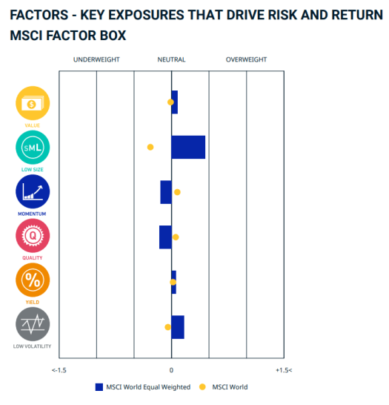

Do like the size factor? Pick EW. Do you like momentum? Pick MCW. Anyone is free to pick his own poison but let’s not forget that any factor strategy can go through decades of underperformance. Check how two of the best (source: me) factor funds performed since VMOT was launched:

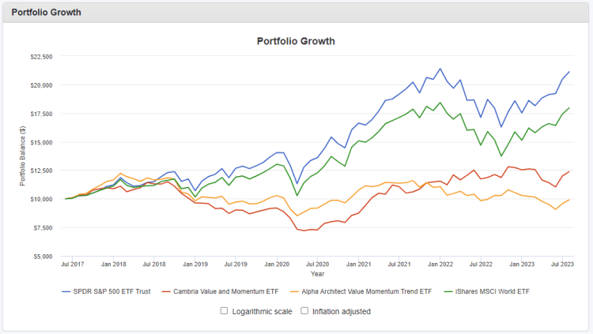

Is it still so easy to explain to yourself that an MCW index is stupid? One thing is to say that even the S&P500 suffered lost decades (and it will happen again in the future), one thing is thinking you can profitably time the next one. Show. Me. Your. Plan.

Last item, a very particular category that I do not understand: investors that increase their home country’s stock exposure to…lower risks. What risk are you reducing, again? I guess only the risk to achieve better returns. If you are really worried about FX volatility (but somehow are comfortable with stocks volatility?), just currency hedge part of the portfolio. Why would you prefer a stock simply because it is listed in your currency? If you are worried about valuations, see above. And if you are worried that you would lose relatively to the people around you, because the GDP of the place where you live is going to the moon, I guess the only valid hedge is to find a better job that would keep your ass tied to the rising tide.